DATA ANALYSIS INTERNSHIP – DAY 17 REPORT
Organization: Top Tech Developers
Topic Covered: Sales & Revenue Analysis Dashboard using Power BI

Introduction
Microsoft Power BI is a business intelligence and data visualization tool used to create interactive dashboards and reports. It helps organizations analyze business data using charts, KPI cards, slicers, and filters for better decision-making.
On Day 17 of the internship, a Sales & Revenue Analysis Dashboard was created using Microsoft Power BI to analyze revenue performance based on products, regions, categories, and sales dates. Different visualizations and interactive filtering techniques were implemented to improve business analysis and reporting.

1. Dashboard Visualizations Used
Different dashboard visuals were created to represent sales and revenue data effectively.

1. KPI Cards
KPI cards were created to display important business metrics.
KPI Values
KPI Metric | Value
Total Revenue | 330K
Total Sales | 29
Average Revenue | 32.96K
Purpose
- Provides quick business performance overview
- Displays important numerical insights clearly
- Helps users identify overall revenue statistics instantly
Observation
- KPI cards improved dashboard readability
- Important metrics became easier to analyze quickly
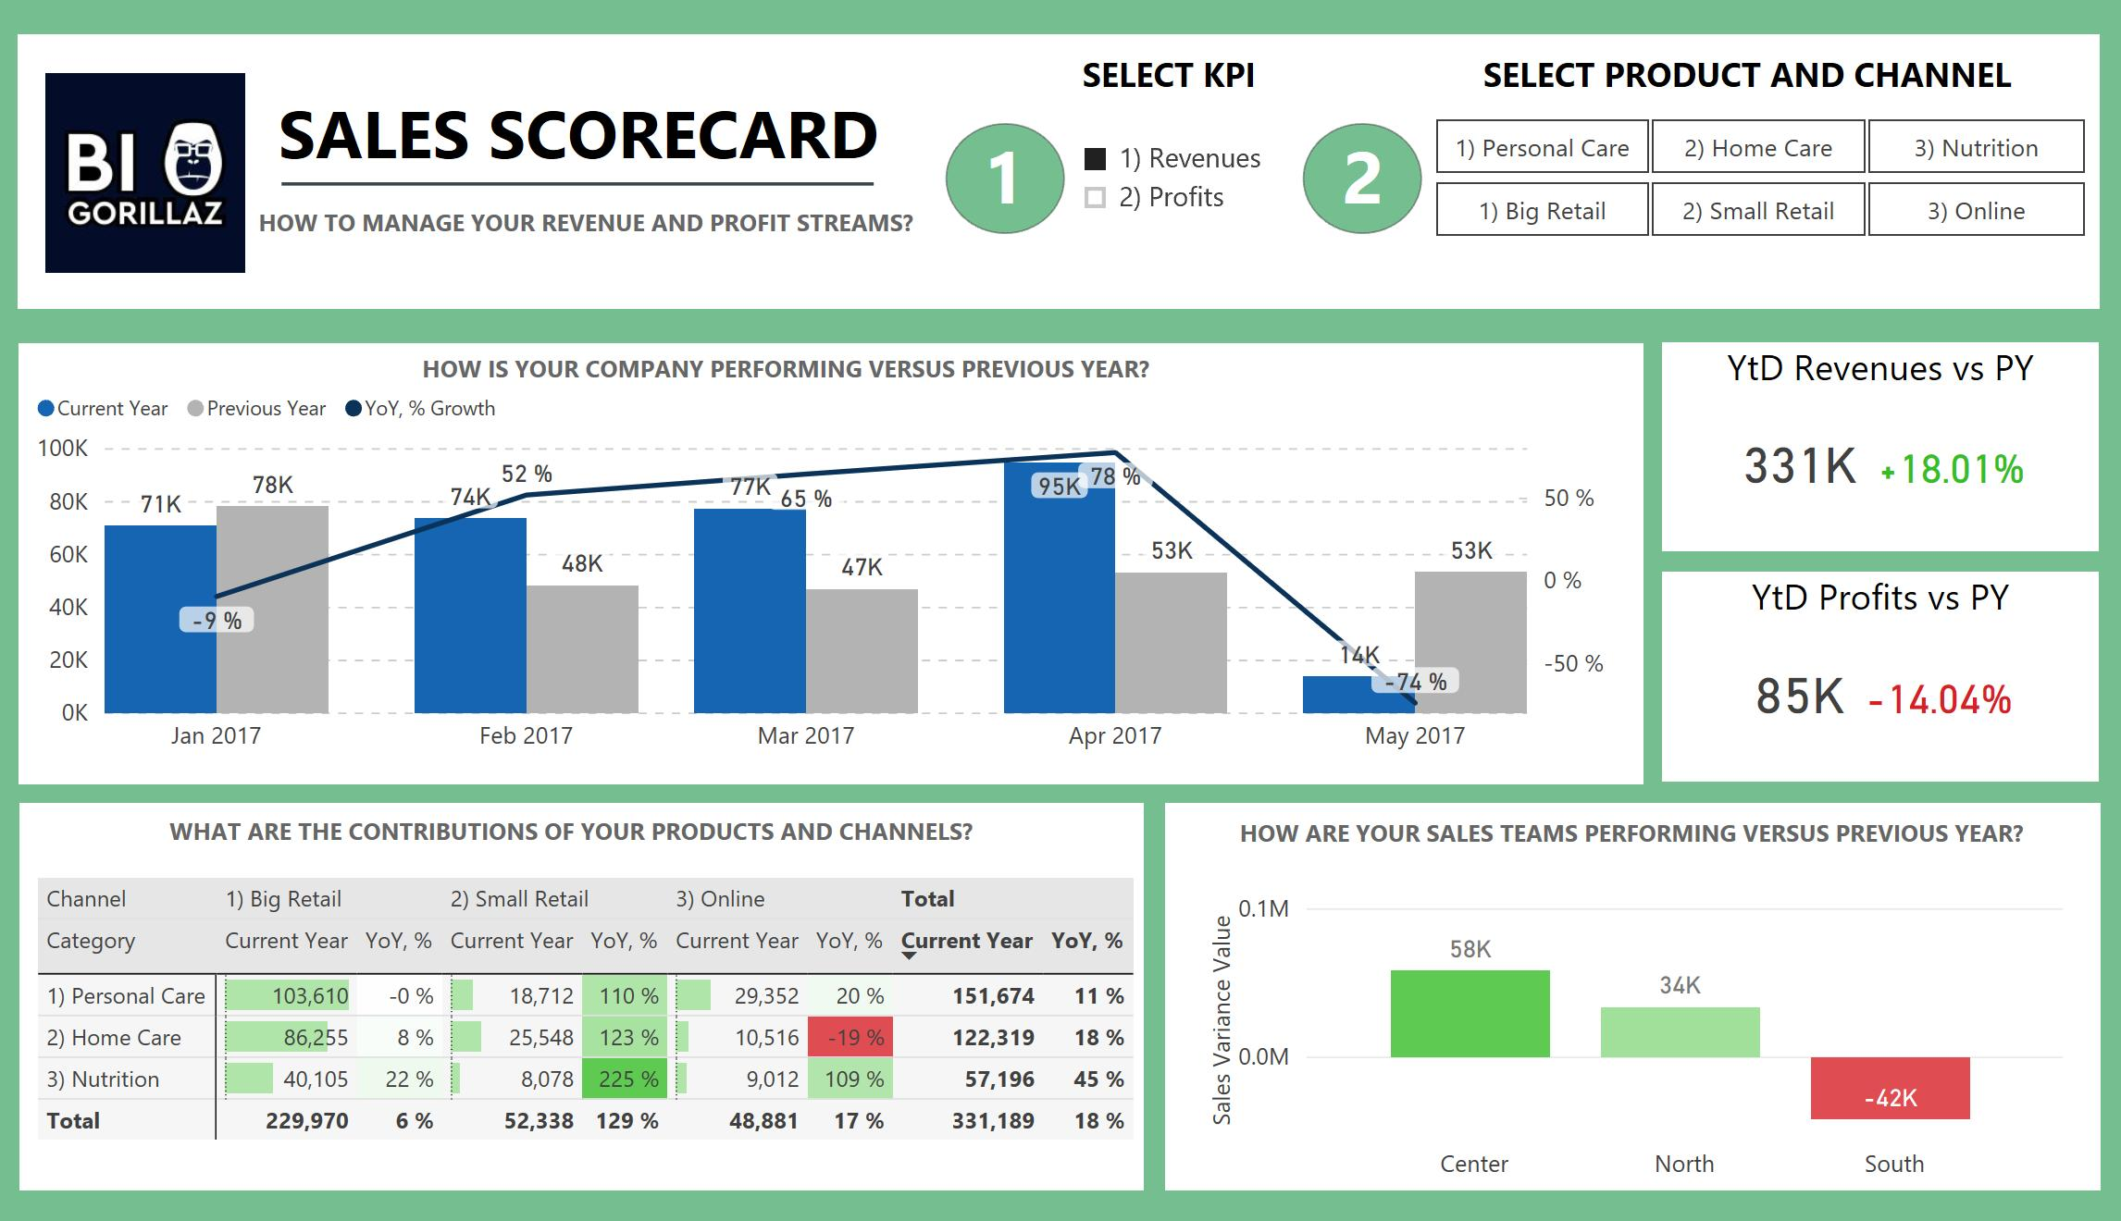
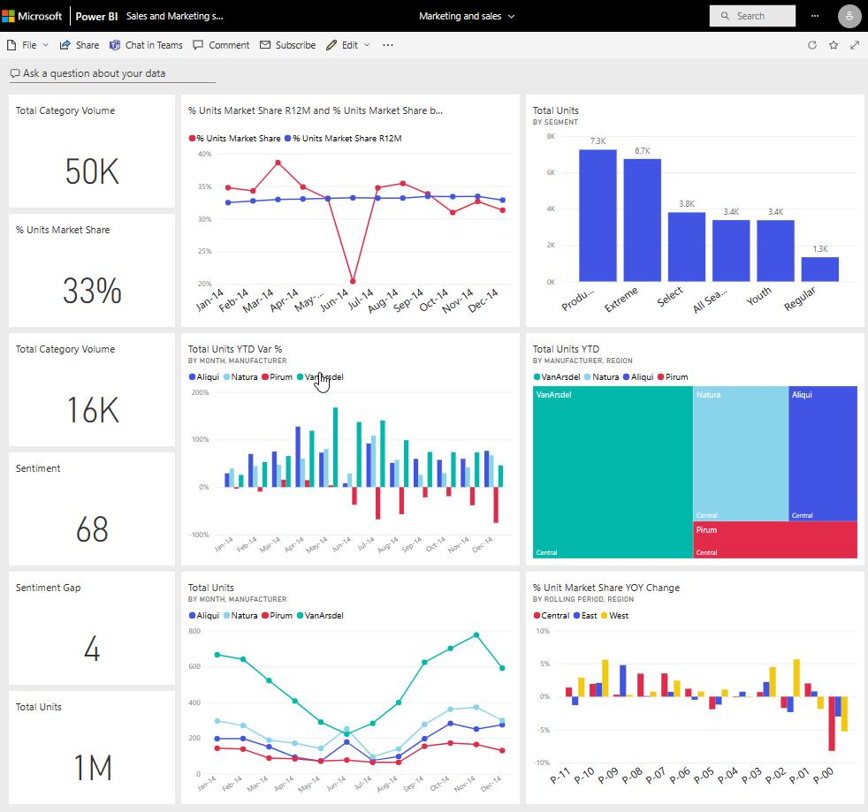
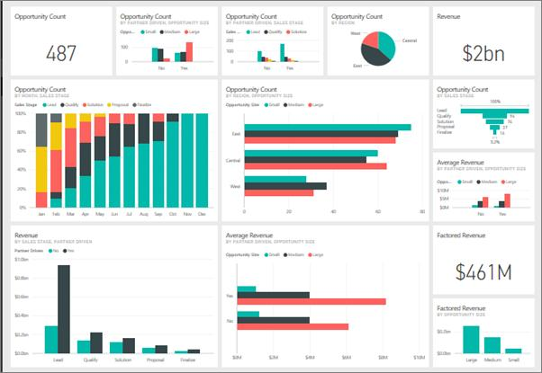
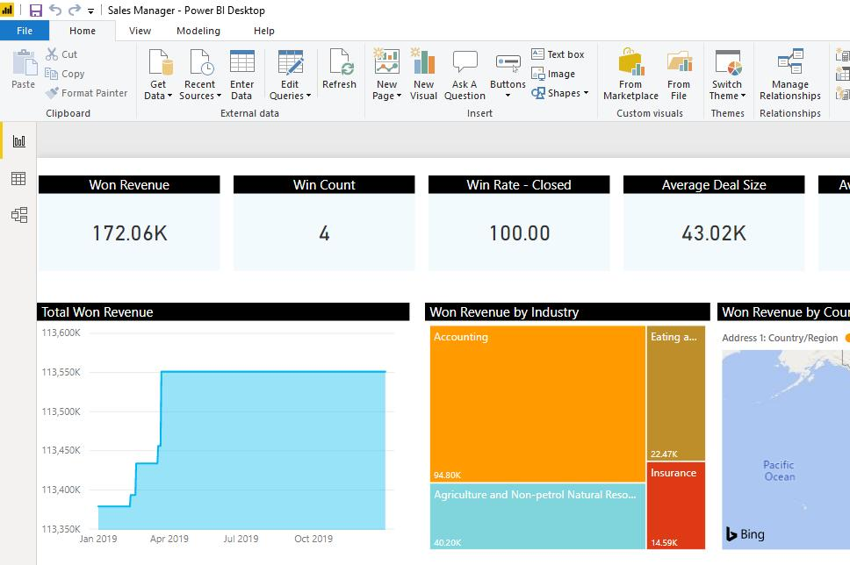
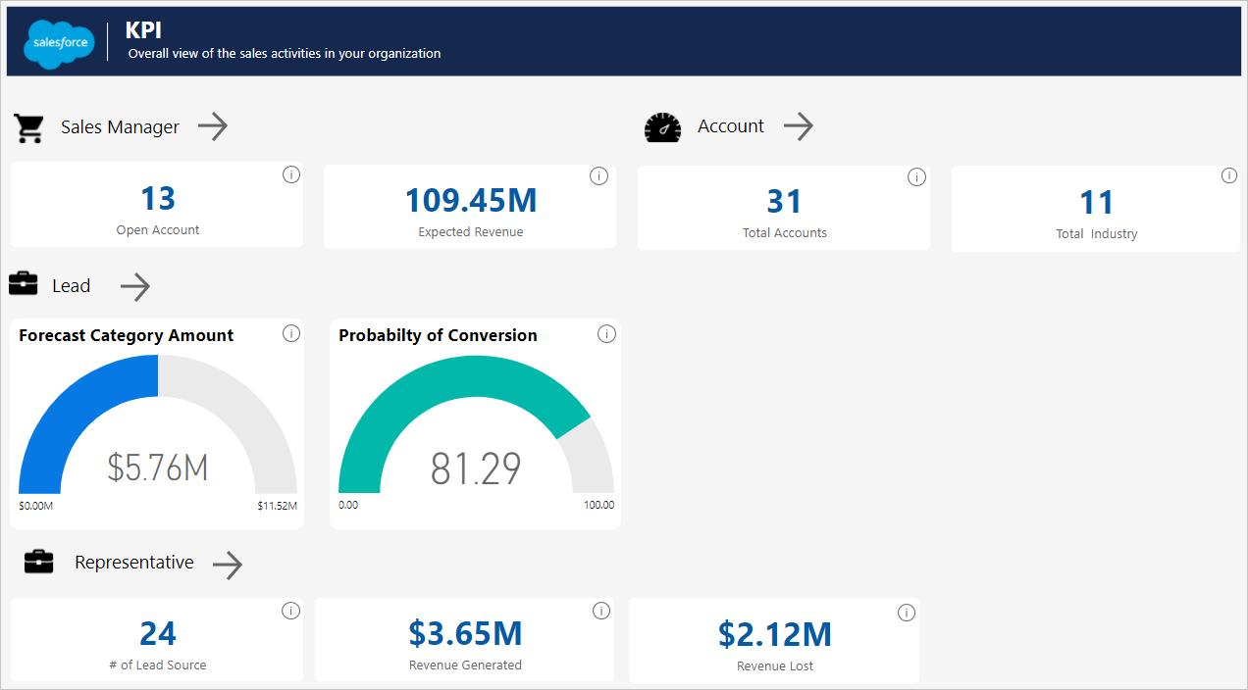

2. Bar Chart – Sum of Revenue by Product
A bar chart was created to compare revenue generated by different products.
Products Included
- Laptop
- Mobile
- Tablet
- Shoes
- Headphones
- Watch
- Bag
Purpose
- Compares product-wise revenue performance
- Identifies products generating higher sales revenue
Observation
- Laptop generated the highest revenue among all products
- Some products contributed lower revenue comparatively

3. Bar Chart – Sum of Revenue by Region
A regional revenue comparison chart was created.
Regions Included
- Chennai
- Madurai
- Coimbatore
- Salem
- Trichy
Purpose
- Analyzes revenue contribution from different regions
- Helps identify top-performing sales locations
Observation
- Certain regions generated higher sales revenue
- Regional analysis improved business understanding
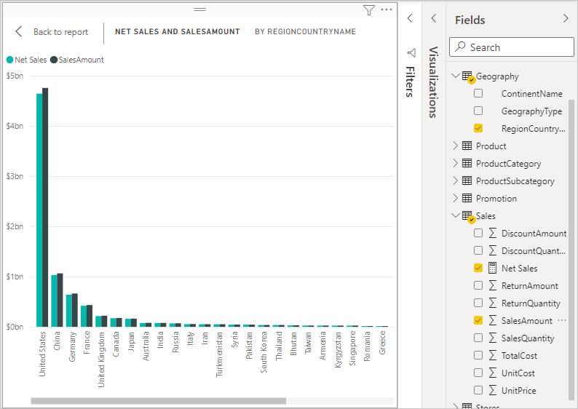
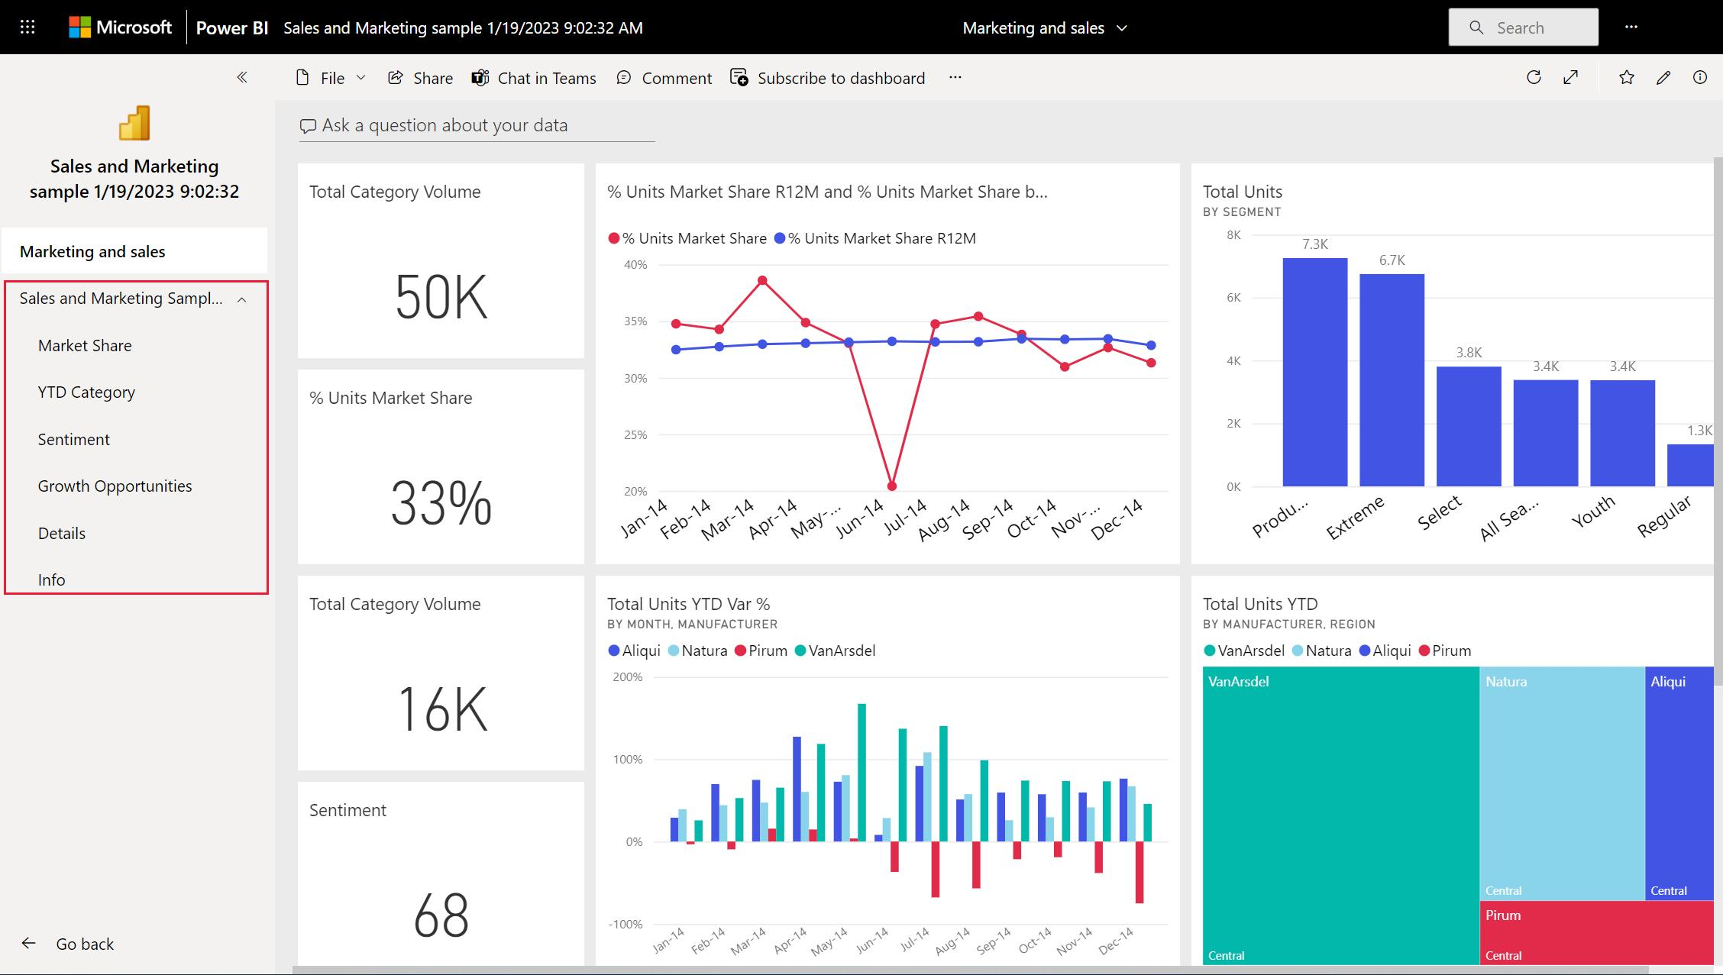
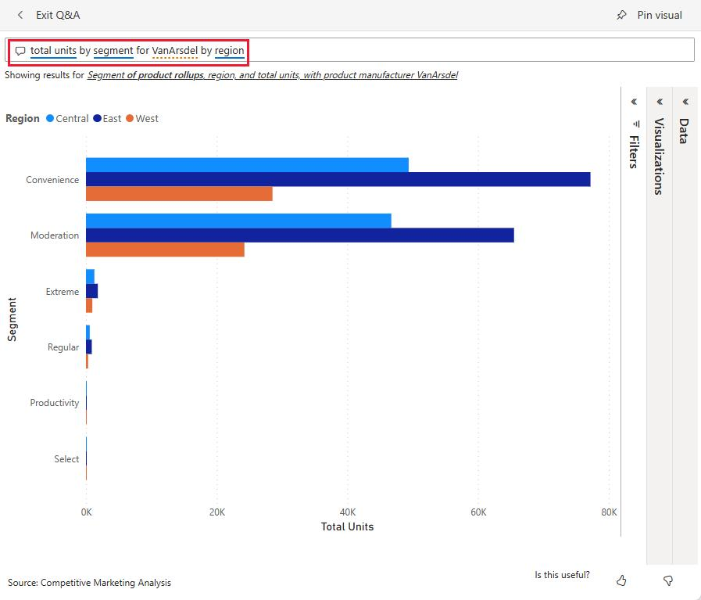
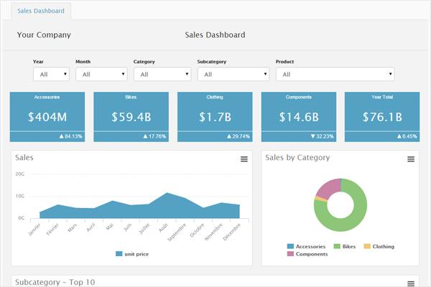

4. Pie Chart – Sum of Revenue by Category
A pie chart was created to display category-wise revenue distribution.
Categories Included
- Electronics
- Fashion
Purpose
- Represents percentage contribution of each category
- Helps compare business categories visually
Observation
- Electronics contributed the highest percentage of revenue
- Pie chart simplified category comparison effectively

5. Line Chart – Revenue Trend Analysis
A line chart was added to analyze revenue trends across different dates in January.
Purpose
- Shows daily revenue changes over time
- Identifies increase and decrease patterns in sales
Observation
- Revenue fluctuations became easier to understand
- Trend analysis supported better business insights
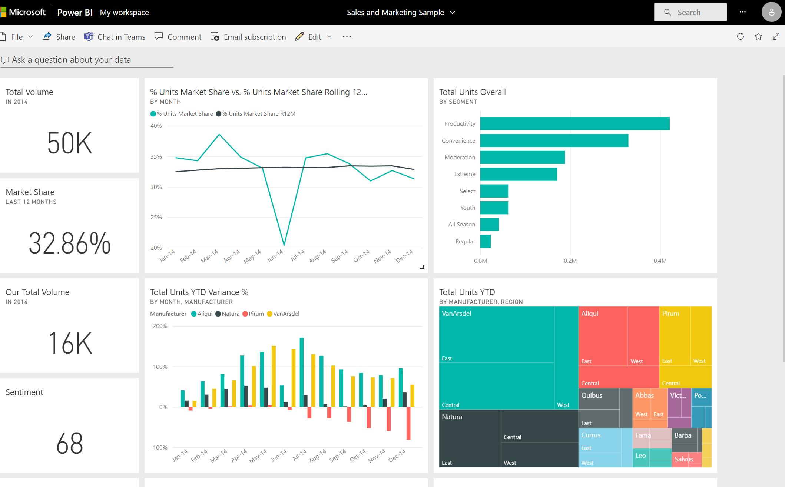
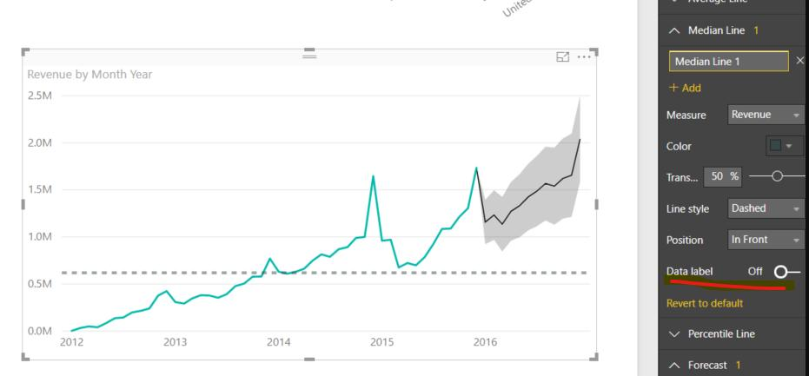
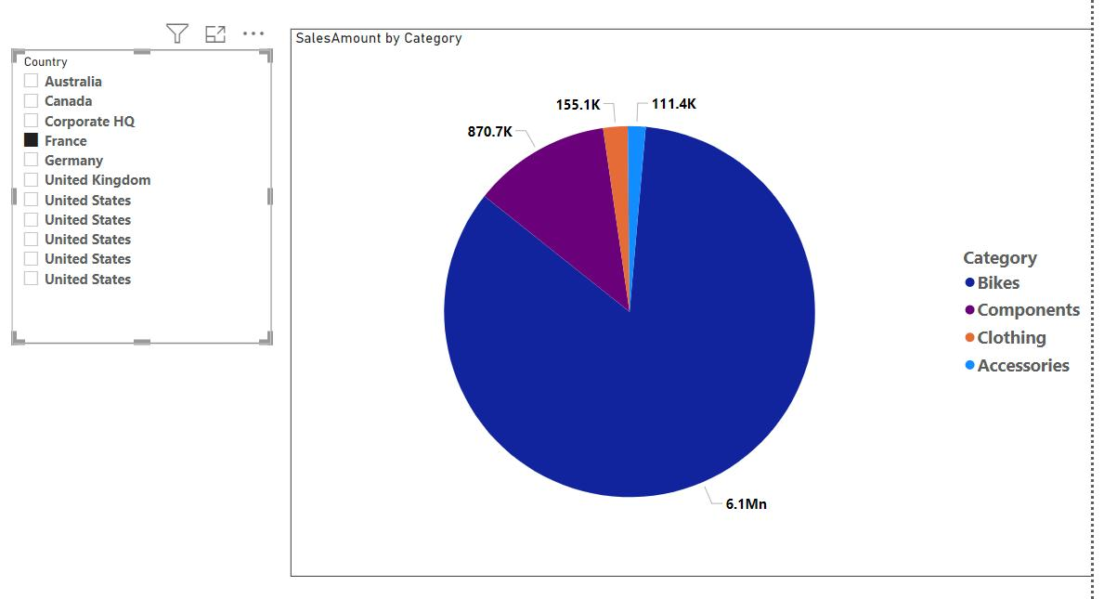
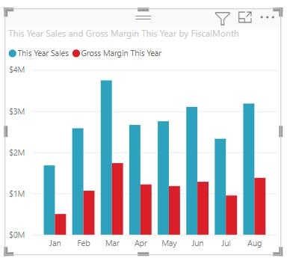
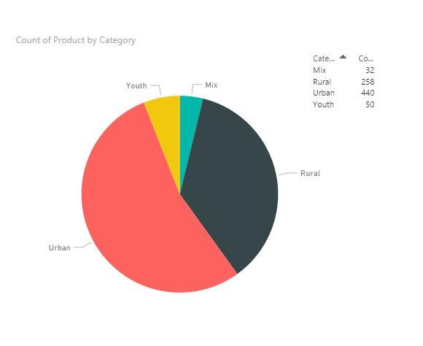
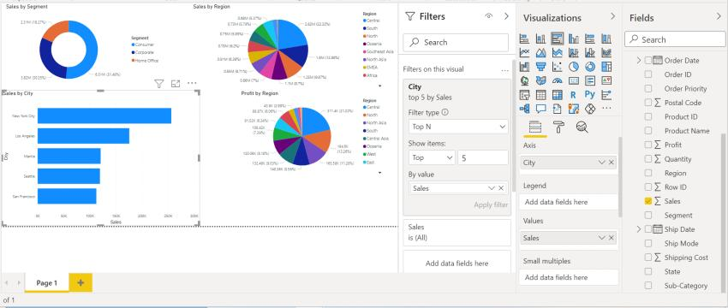

2. Interactive Features Added
Interactive filtering components were added to improve dashboard usability.
Slicers and Filters
Interactive slicers were created for:
- Product
- Region
- Category
- Date
Purpose
- Allows users to filter dashboard data dynamically
- Helps perform customized analysis easily
Observation
- Slicers improved dashboard interactivity
- Users could analyze selected data quickly

Date Range Slider
A date slider was added for filtering records between selected dates.
Purpose
- Helps analyze data within a specific time range
- Simplifies trend-based analysis
Observation
- Date filtering improved flexibility in analysis
- Revenue trends became easier to study

3. Dashboard Design and Formatting
Different dashboard formatting techniques were applied to improve appearance and readability.
Design Features Applied
- Green-themed dashboard background
- Proper alignment of visuals
- Border customization
- Spacing and layout organization
- Visual formatting improvements
Observation
- Organized visuals improved dashboard presentation
- Better formatting enhanced readability and user experience
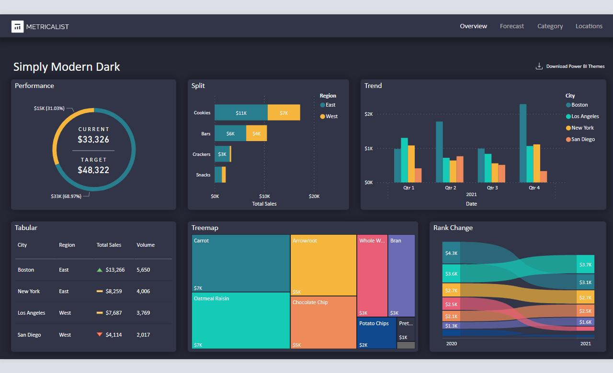

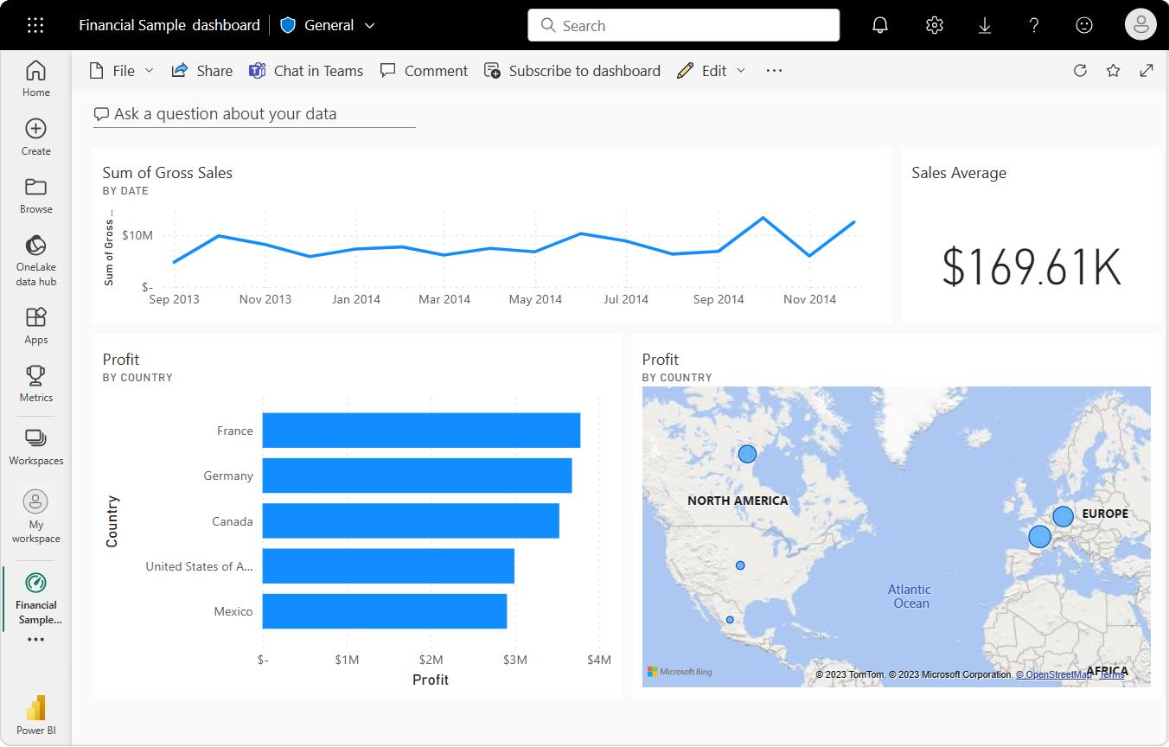
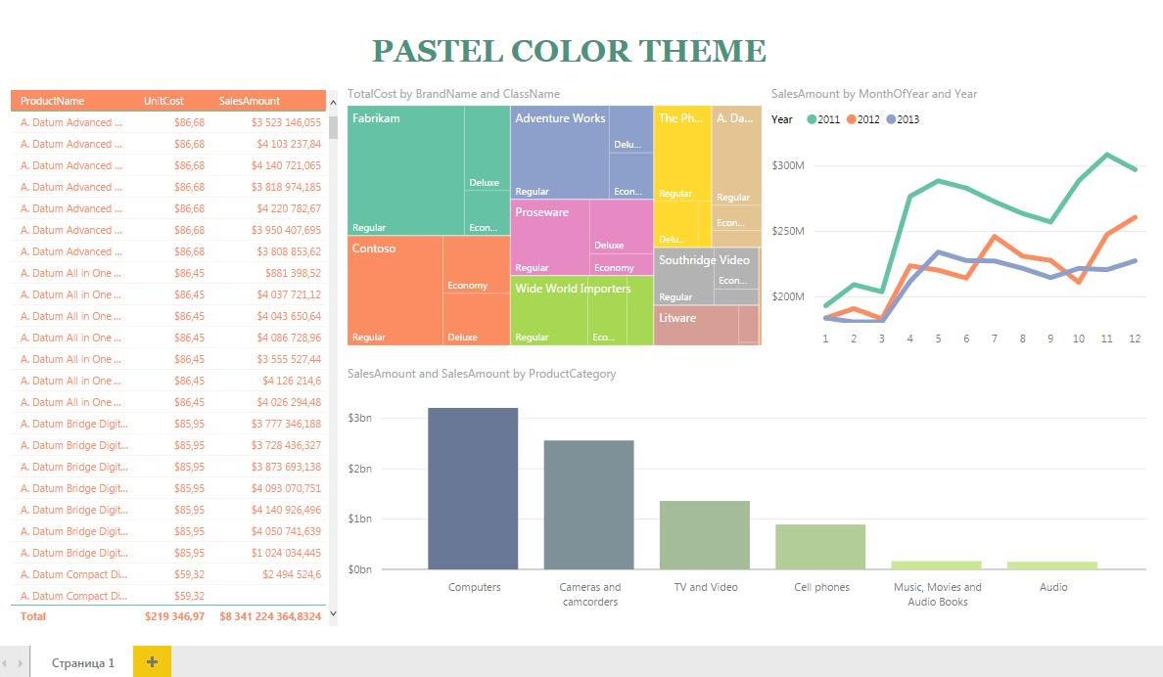

Tools Used
- Microsoft Power BI
- Microsoft Excel
- Data Visualization
- Dashboard Design
- Business Analytics

Outcome
The Sales & Revenue Analysis Dashboard was created successfully using multiple visualizations and interactive filters.
The dashboard provided meaningful insights into:
- Product performance
- Regional revenue contribution
- Category-wise distribution
- Sales and revenue trends

Learning Outcome
On Day 17, I learned how to create business dashboards using Microsoft Power BI.
I understood:
- how to create KPI cards and charts
- how to analyze business revenue data
- how to apply slicers and filters
- how to design interactive dashboards
- how visual analytics improves business decision-making

Conclusion
The Day 17 internship session helped me understand business data visualization and dashboard creation using Microsoft Power BI.
Different visualizations such as KPI cards, bar charts, pie charts, and line charts were used successfully to analyze sales and revenue performance. Interactive slicers, filters, and date range selection improved dashboard usability and analysis. This session enhanced my practical knowledge of business intelligence, dashboard design, and interactive data visualization.

